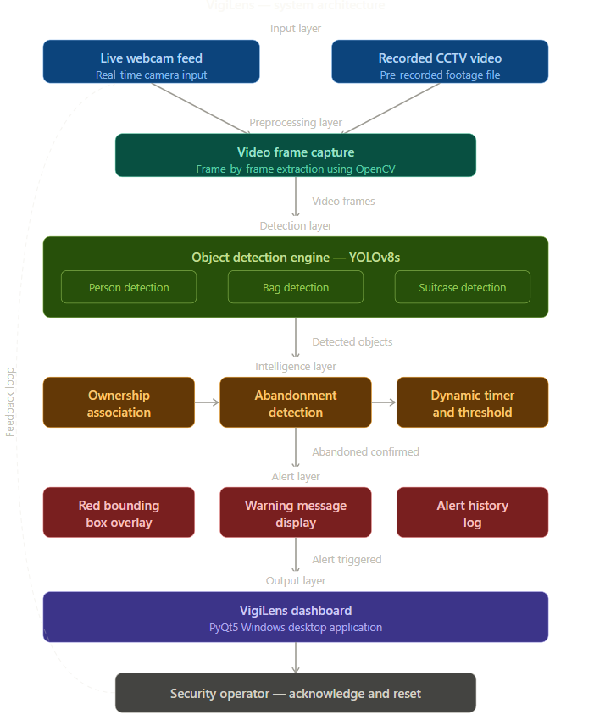
Figure 1:System Architecture Diagram of Vigilens — Real-Time Video Surveillance System for Detection of Abandoned Objects

